Sustainable Development Goals assignment

Anarosa Simon

Environmental Sciences

27 Nov 2017

# SDG: Peace, Justice and Strong Institutions

# Target: Significantly reduce all forms of violence and related death rates everywhere

Indicators:

1. Number of victims of intentional homicide per 100,000 population, by sex and age
2. Conflict-related deaths per 100,000 population, by sex, age and cause
3. Proportion of population subjected to physical, psychological or sexual violence in the previous 12 months
4. Proportion of population that feel safe walking around the area they live

# Describe what SDG target and goal your indicator is monitoring and how:

The indicators are monitoring the levels of armed violence, homicides, insecurity, sexual violence, crime and torture that have a negative impact on the development of a country, which may affect economic growth and grievances among communities. The indicators aim to significantly reduce all forms of violence, and work with governments and communities to find lasting solutions to the conflicts and insecurities. The most important part of this process is to strengthen the rule of law and promote human rights, and also by reducing the flow of illicit arms and strengthening the participation of developing countries in the institutions of global governance.

# Why is this SDG target and goal important to Aruba?

The goal applies to Aruba because people everywhere need to be free of fear from all types of violence and feel safe as they go about their lives whatever their ethnicity, faith or sexual orientation. Crimes that threaten the foundation of peaceful societies, including  
homicides, sexual abuse and other organized crimes, affect all countries, so it also effects Aruba. Any of these types of crime can affect a person’s health, development and well-being. It causes trauma. Having a lack of access to justice means that conflicts may remain unresolved and people cannot have protection. Institutions that do not function according to the laws are most likely to abuse of power, and less capable of delivering public services to everyone. This causes rise to violence.

# How does this SDG target and goal relate to waste management in Aruba?

Because laws in Aruba are not strict enough people don’t care about throwing their waste anywhere they like, creating illegal dumpsites, which creates more risks to human health. The dumpsite at Parkietenbos, some waste is being burned, which is illegal. If there is no strict law against this it will continue to happen, because no one stops them. By implementing policies it can help with the reaching of the SDG goal in 2030. One other influencer is bribery and corruption, rules get broken all the time with no consequences, no importance to the environment.

# Find out if the described indicator is being monitored in Aruba:

* + If so, who collects it? If possible, include a link or reference to the data.
  + If not, describe where you inquired, and what the response was (e.g. CBS).

I called CBS and they gave me the email of the person that focuses on the SDG 16, I emailed her but I gaven’t gotten a reply. I went to CBS’s website to see what I could find and based on their info I concluded that they are working on developing a system of crime and criminal justice statistics on the island. Until recently, they do not have national standards to which all stakeholders adhere to and there is a lack of common data definition. I looked further on other websites and found out that The UN office of drugs and crime has a statistic of intentional homicides for Aruba from 2002-2010.

## Aruba: Homicides per 100,000 people

: For that indicator, The UN office on drugs and crime provides data for Aruba from 2002 to 2010. The average value for Aruba during that period was 5.77 homicides per 100,000 people with a *minumum of 2 homicides per 100,000 people in 2004* and a *maximum of 12 homicides per 100,000 people in 2005*.

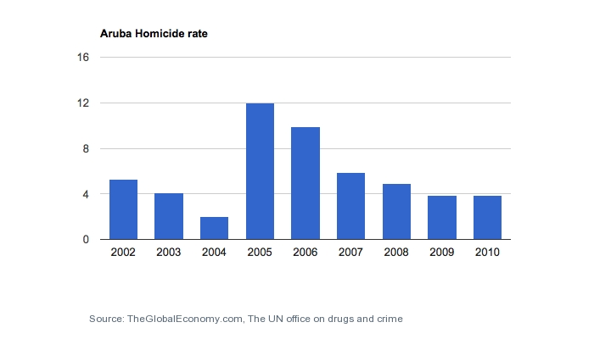

I searched online and the info I found was that there are several organizations that mostly try to raise awareness. Two organizations that caught my eye were the SDG Aruba on facebook and FHMD(Fundacion Hende Muhe den Dificultad). These two organizations raise awareness in our community about the realities of violence and the importance of peaceful and just societies. This is part of the work that the FHMD and SDG Aruba does. The other part is geared towards prevention. However, because of lack of funding this goal has remained mainly in giving advice when asked for and lectures when requested. The Government of Aruba recognizes Human Rights in accordance with the United Nations’ Universal Declaration of Human Rights and is dedicated to, among others, improving the rights of women, minorities and workers, and combating human trafficking. Aruba is a committed partner engaging in close cooperation with the Kingdom and international partners to enhance security, peace and prosperity within the region. However, work is still to be done in regard to transparency and accessibility to information.

<http://www.un.org/sustainabledevelopment/peace-justice/>

<http://www.undp.org/content/undp/en/home/librarypage/sustainable-development-goals/undp-support-to-the-implementation-of-the-2030-agenda/>

<https://sustainabledevelopment.un.org/sdg16>

<https://www.brookings.edu/blog/future-development/2015/10/01/how-can-we-implement-sustainable-development-goal-16-on-institutions/>

<http://www.theglobaleconomy.com/Aruba/homicide_rate/>

<https://data.worldbank.org/indicator/VC.IHR.PSRC.P5?end=2010&locations=AW&start=2002&view=chart>